UNIT INSTRUCTIONAL OBJECTIVES, Chapter 4, Section 1, Angles and Their Measures, Pages 312 – 317, 322 – 327.
Students will understand and apply the following concepts:
- Angular measure in degrees, minutes, seconds
- Conversion of angles in degrees, minutes, seconds to decimal degrees
- Conversion of angles in decimal degrees to degrees, minutes, seconds
- Definition of radian measure
- Conversion of radians to degrees
- Conversion of degrees to radians
- Use of the TI-83/84 to do the above conversions
- Computation of arc length (radian measure)
- Computation of arc length (degree measure).
- Use of the unit circle to understand the association between radians and degrees
- Computation of area of a sector
- Definitions of the 6 trigonometric functions using right triangle trigonometry.
- Trigonometric Values for the Special Angles of 30º, 60º, and 45º.
- Applications of right triangle trigonometry.
- Definitions of the 6 trigonometric functions using unit circle trigonometry.
Technology: Graphing calculator (TI-84)
TUESDAY (8.27.24
- Test: Radians, Degrees, Arc Length, Area of a Sector, Conversions
You may use your notes written on one page of paper (8.5 by 11 inches).
- Class Work/Homework:
Read and take notes on pages 322 – 327.
Quick Review, 4.2, page 327, #1 – 10.
Exercises, page 328, #1 – 7, odd.
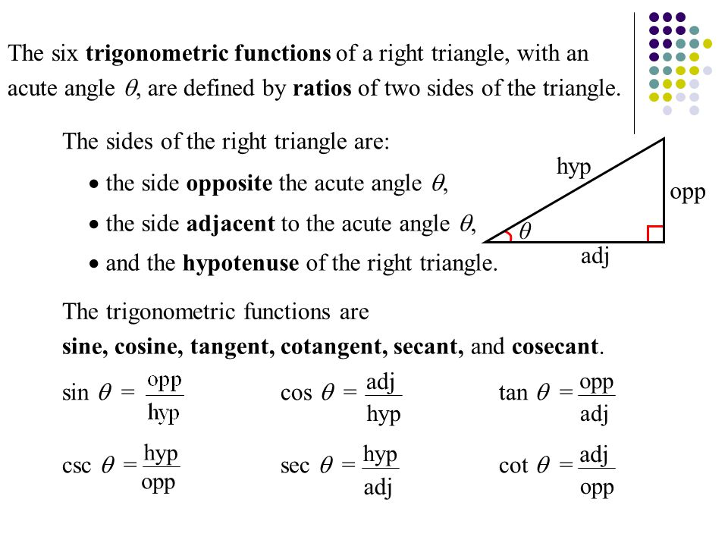

THURSDAY (8.29.24)
- Discuss the previously assigned problems.
- Class Work/Homework: Page 328, #9 – 17 odd, 49, 51, 53, 55.
FRIDAY (8.30.24)
- Discuss the previously assigned problems.

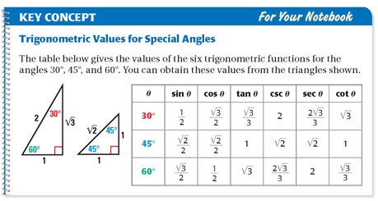
- Class Work/Homework:
- Page 328, #19 – 47 odd, 57
- Page 329, #61
- Practice filling out the degrees/radians on a blank unit circle.

